**Jenkins:**

it is a tool which can automate the process of integration and much more

it is basically used for CI/CD

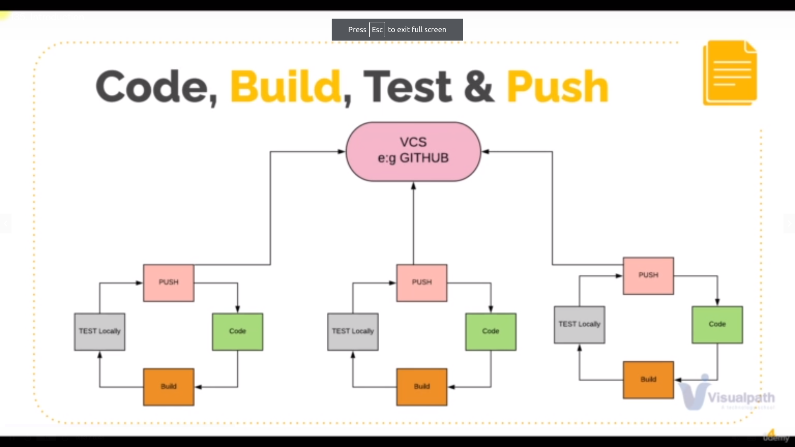problem: continous pushing code to github and not testing makes a lot of errors

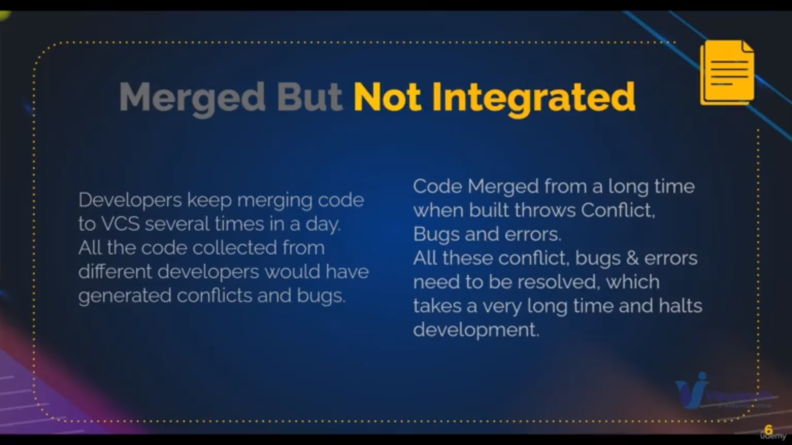

integration is nothing merging the tested code to main branch

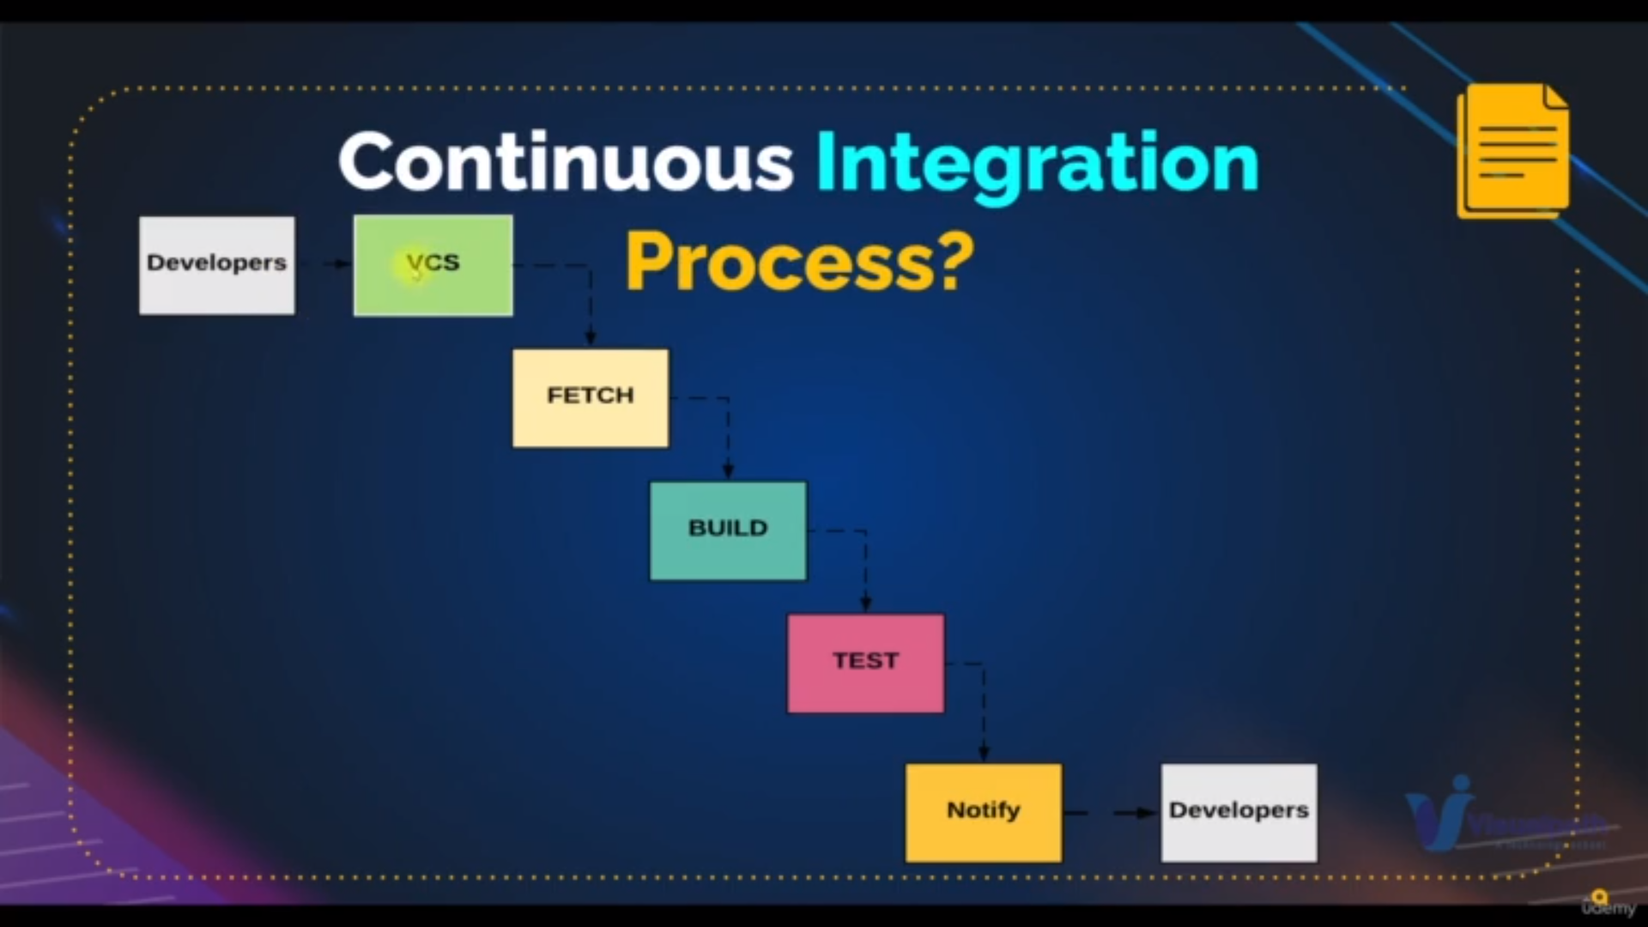process of integration

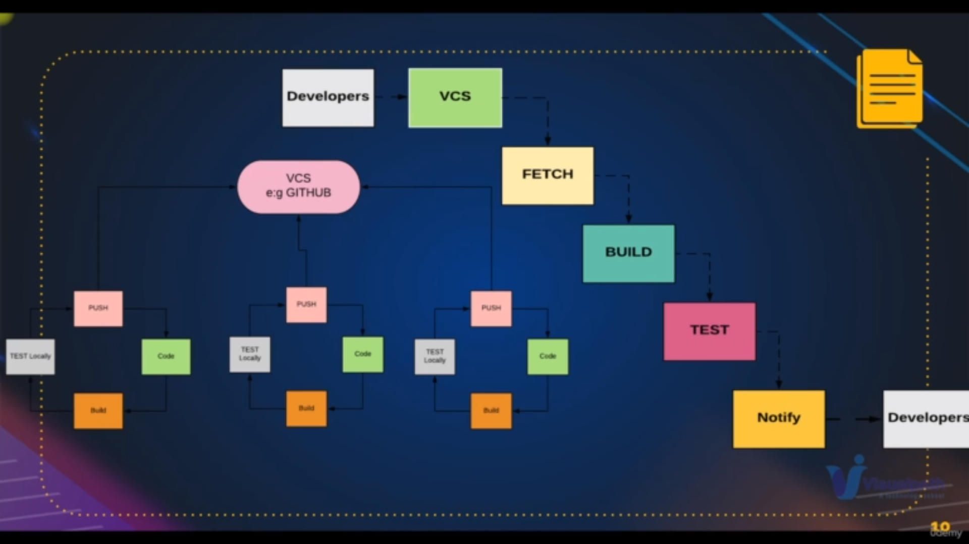flow of how devops works

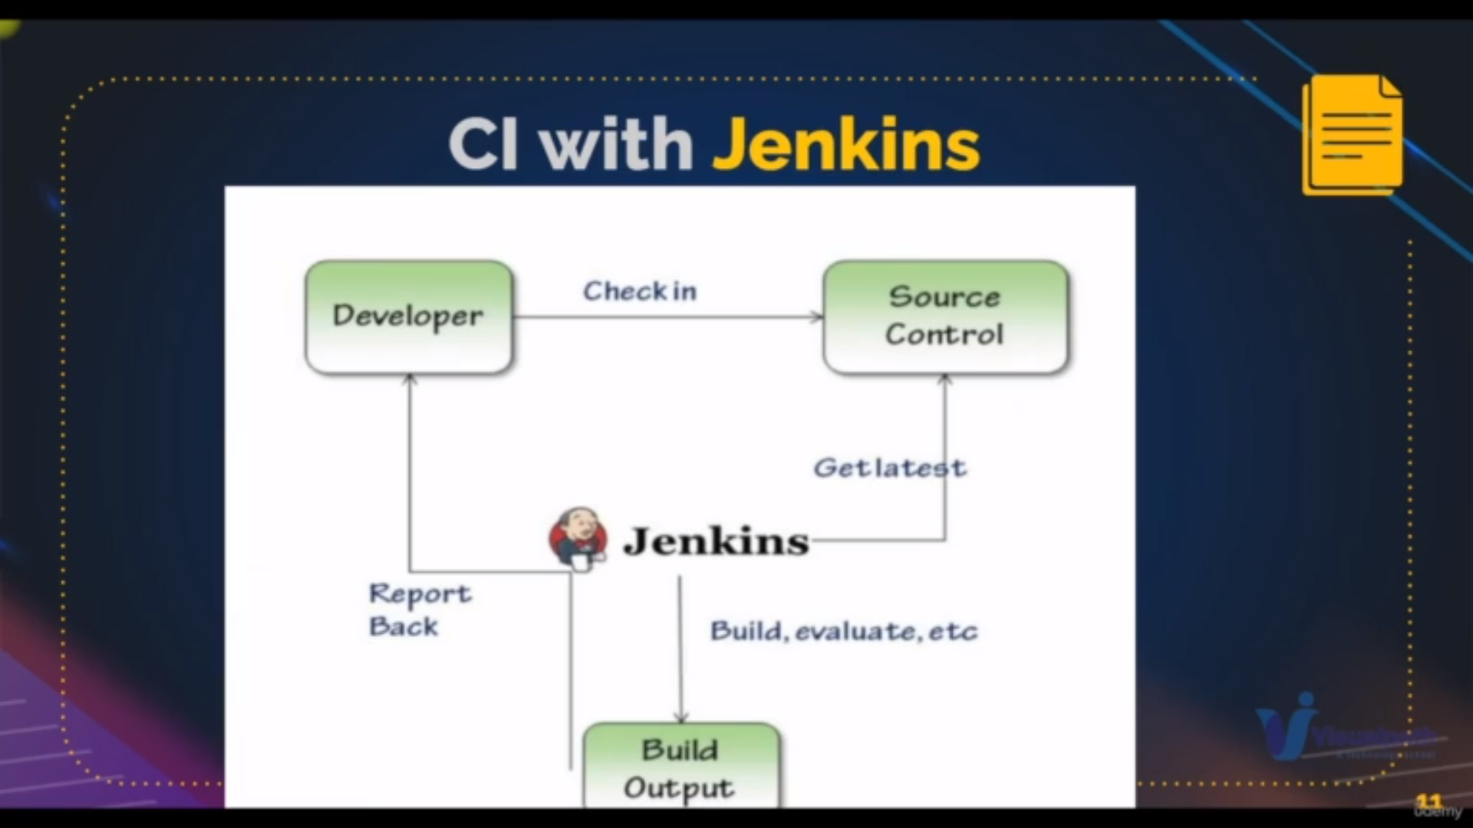basic flow of jenkins

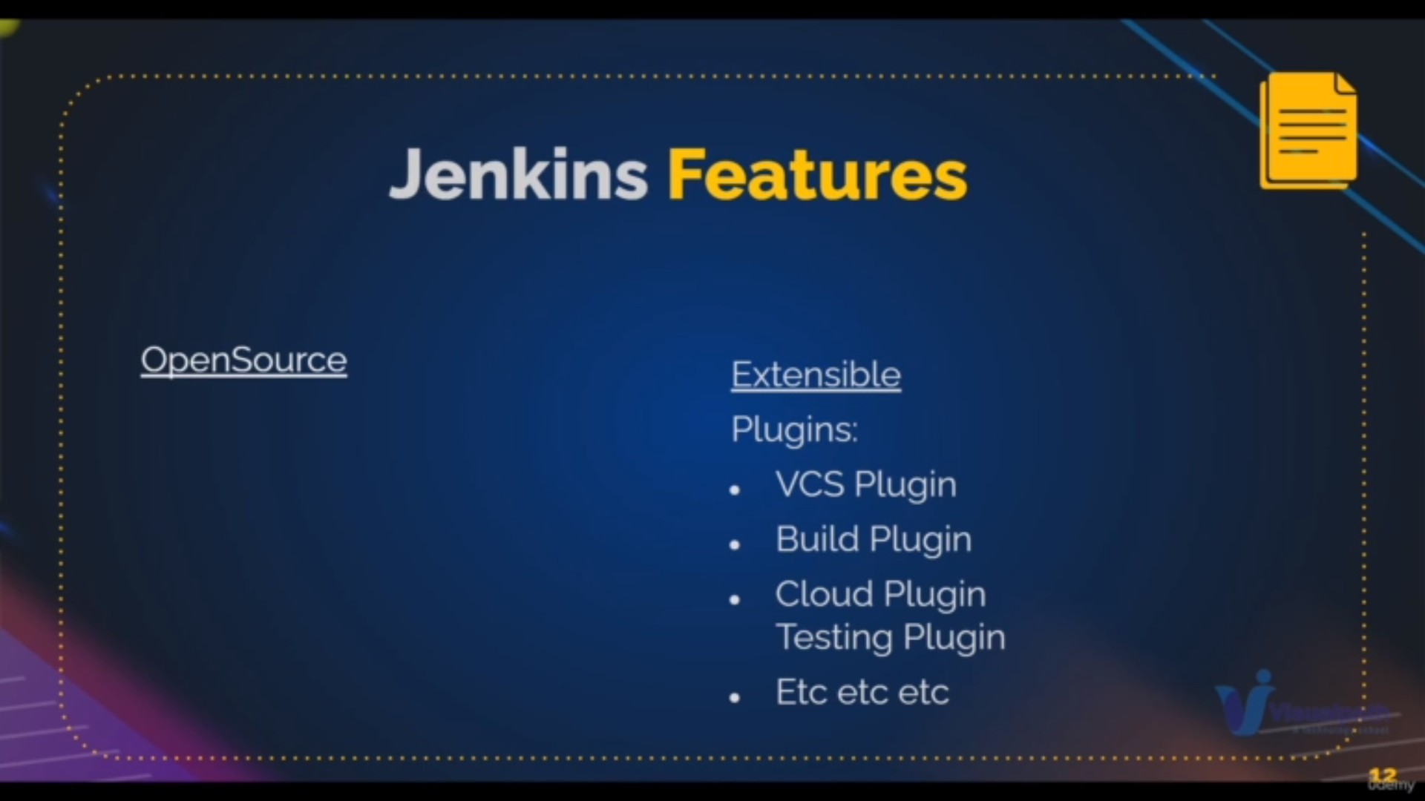features of jenkins

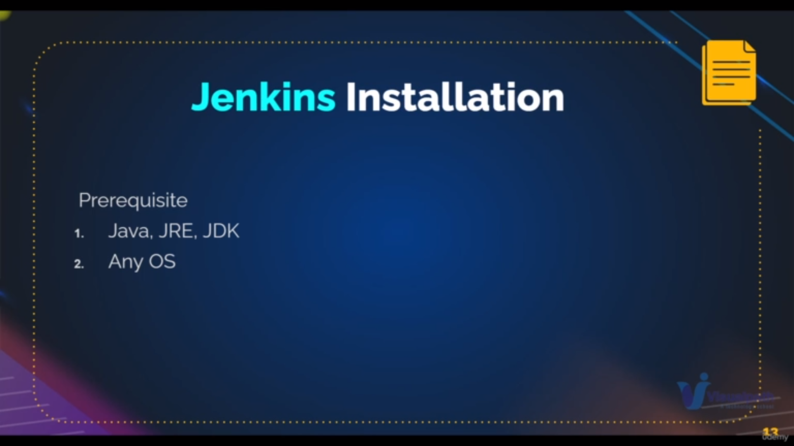**prequistes of jenkins**

**Installation:**

Enter below data with command user data while launching instances

**_____________________________________________________________**

**#!/bin/bash**

**sudo apt-get update**

**sudo apt-get install openjdk-11-jdk -y**

**curl -fsSL https://pkg.jenkins.io/debian-stable/jenkins.io.key | sudo tee \**

**/usr/share/keyrings/jenkins-keyring.asc > /dev/null**

**echo deb [signed-by=/usr/share/keyrings/jenkins-keyring.asc] \**

**https://pkg.jenkins.io/debian-stable binary/ | sudo tee \**

**/etc/apt/sources.list.d/jenkins.list > /dev/null**

**sudo apt-get update**

**sudo apt-get install jenkins -y**

**__________________________________________________________________**

step2: ipaddress:8080 directs you to jenkins page where setup your jenkins with initial thing

like select the plugins and create your first user

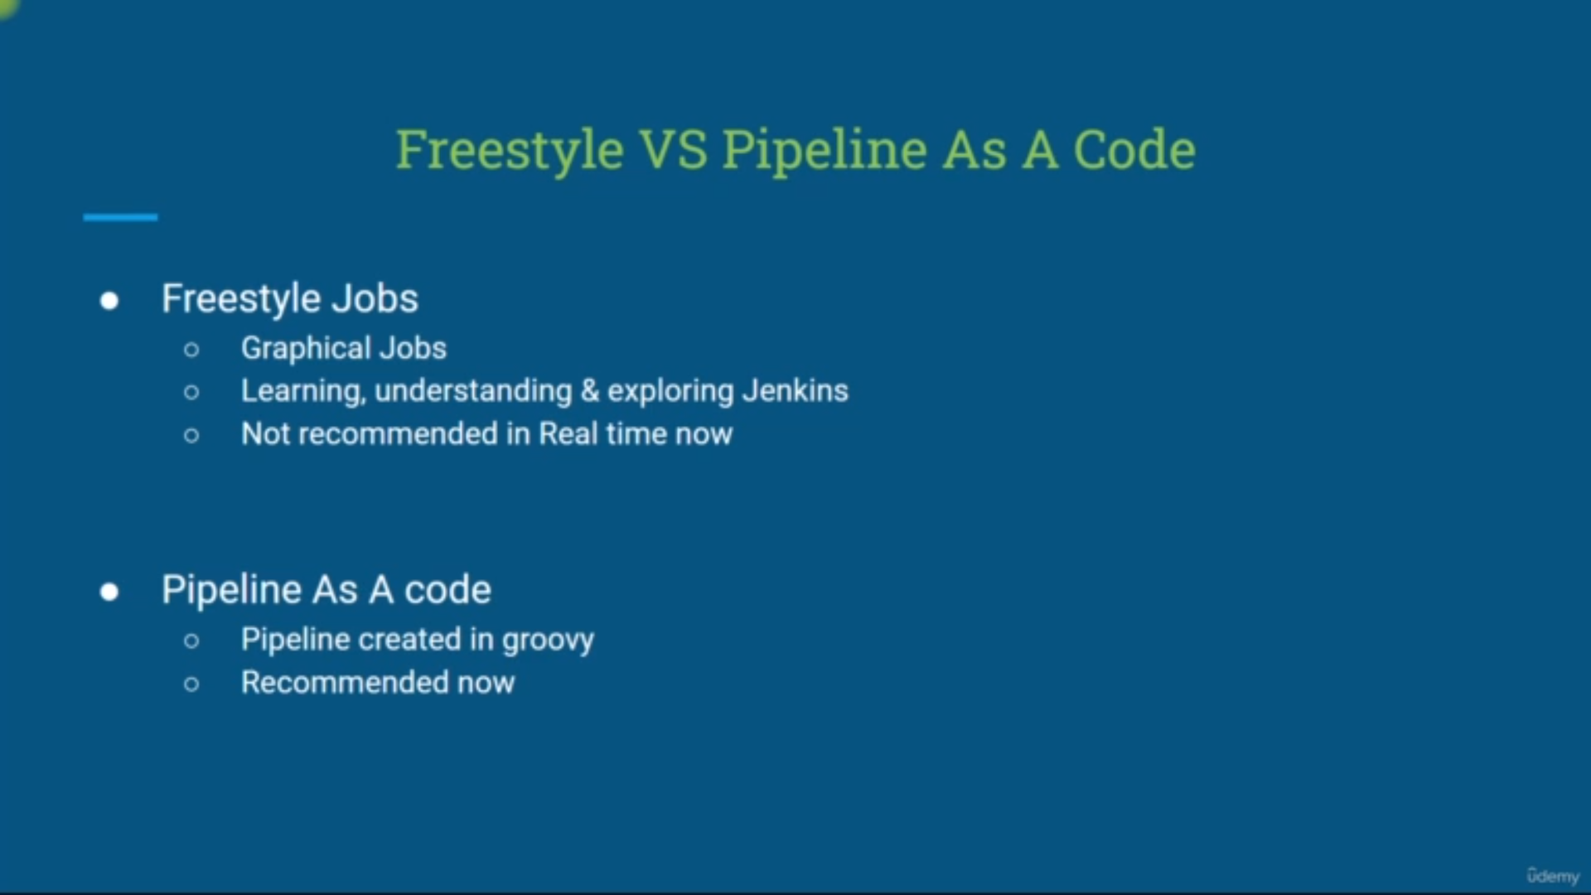Freestyle is for explore and pipeline is for real time projects

**Installing tools in Jenkins:**

before building the job we need some tools to be installed so that we can build the job

Ex: **maven**

for maven we jdk-8 but we installed already jdk-11 so we need to jdk-8 also

**Steps:**

**path:**manage jenkins→Global tool Configuration→ you will find all tools there

step1: add jdk and give the name and path where your jdk-8 is installed

step2: add maven and give the name and check automatically installed

step3: save and continue

FirstJob: